- Mean and Median Unit Price per Category per Platform
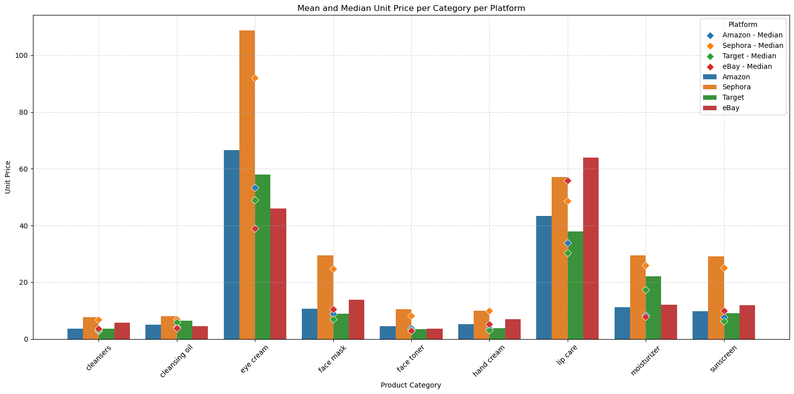
From the plot, we observed that Sephora has overall higher pricing in categories like Eye Cream, Face Mask, and Lip Care. Also, we found that for eBay and Target, mean and median prices are almost overlapping. This suggests a tighter and more uniform price distribution without many extreme values.
- Number of Products per Category per Platform
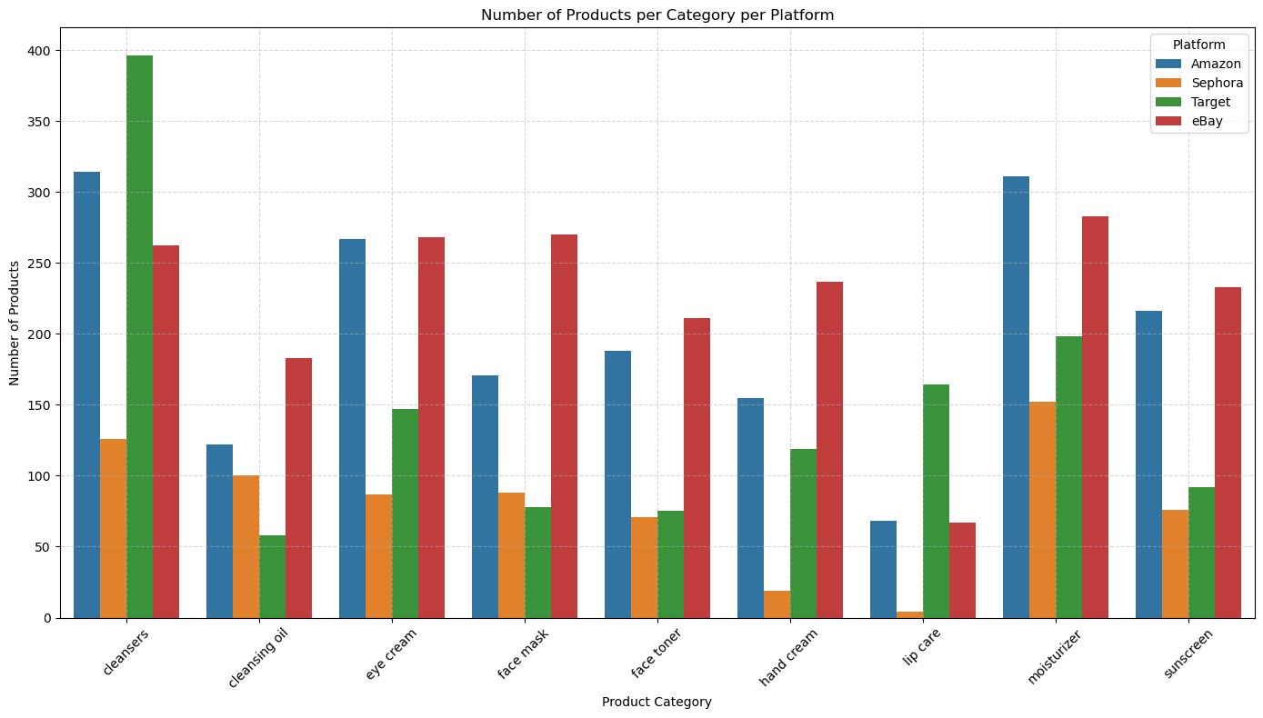
This plot gives users a general overview of how many products were taken into account for each platform. Overall, Amazon and eBay tend to cover a broader range of categories with relatively high product counts, whereas Sephora and Target have more specialized offerings in specific categories.
- Unit Price Distribution by Product Category and Platform
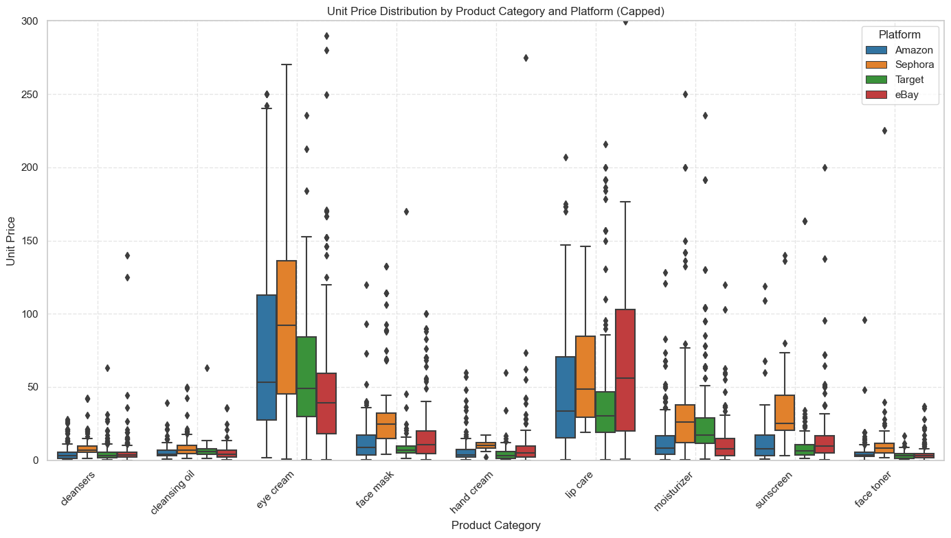
Eye creams and lip care products are the most expensive across platforms, especially on Sephora, while cleansers, hand creams, sunscreens, and toners remain relatively low-priced with minor differences among platforms.

- Unit Price Distribution by Free Shipping Status Across Platforms
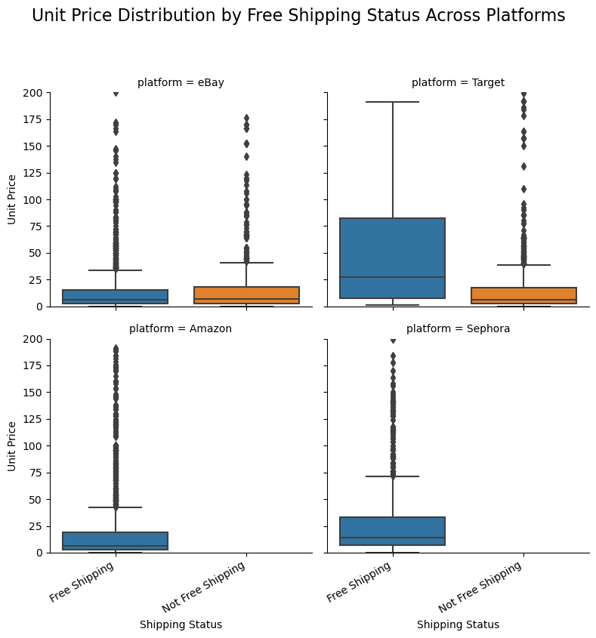
For eBay, there is little difference in median prices between free and non-free shipping products. Overall, prices are concentrated in the lower range. For Target, free shipping products have a significantly higher median price compared to non-free shipping products. Products in Amazon and Sephora are all free-shipping and prices mainly remain in the lower range.

- Unit Price vs Star Rating by Platform
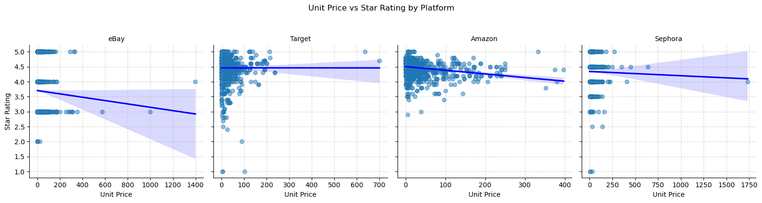
From the plot, eBay shows a strong negative correlation between unit price and rating, Target shows a slight positive trend, and Amazon and Sephora exhibit mild / nearly flat negative trends. This indicates varying consumer sensitivities across platforms.
- Unit Price vs Star Rating with sale status
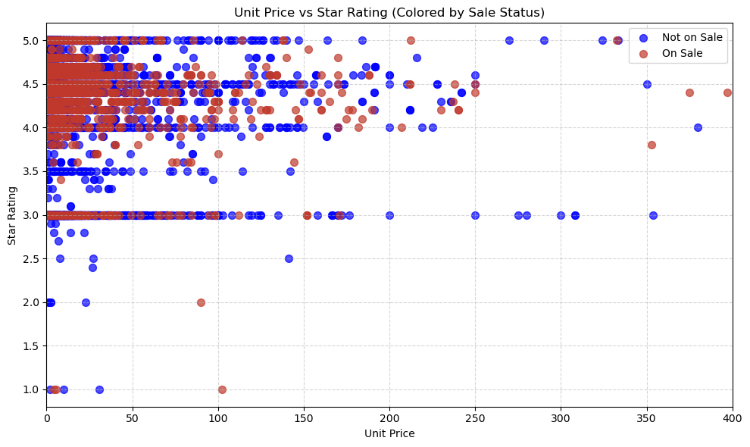
We found beauty products, whether on sale or not, are priced under $100 and generally maintain high star ratings (above 4 stars). Both on-sale and non-sale products include some low-rated items (below 3 stars). The difference between the two groups in terms of price and rating distribution is subtle.

- Price vs Review Counts by Platform
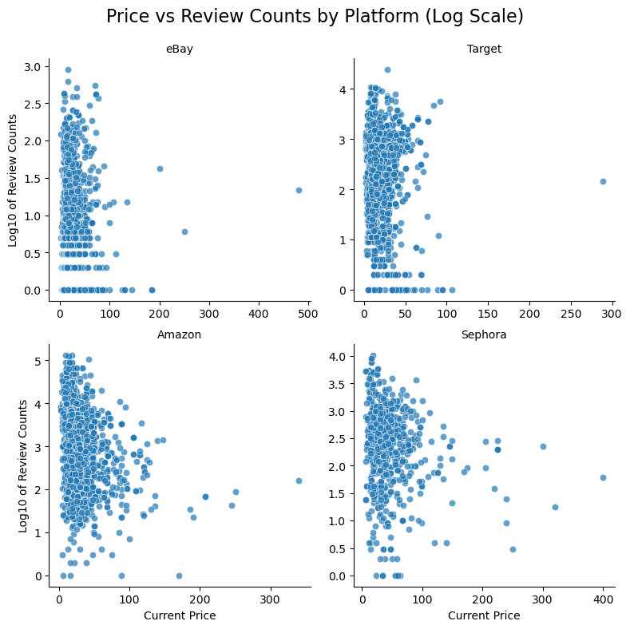
We found that Amazon stands out with significantly higher review counts, especially among low-priced products, while eBay, Target, and Sephora show lower overall review volumes and rare high-priced products with substantial reviews.

- Average Unit Price by Free Shipping and 3-Day Delivery Status
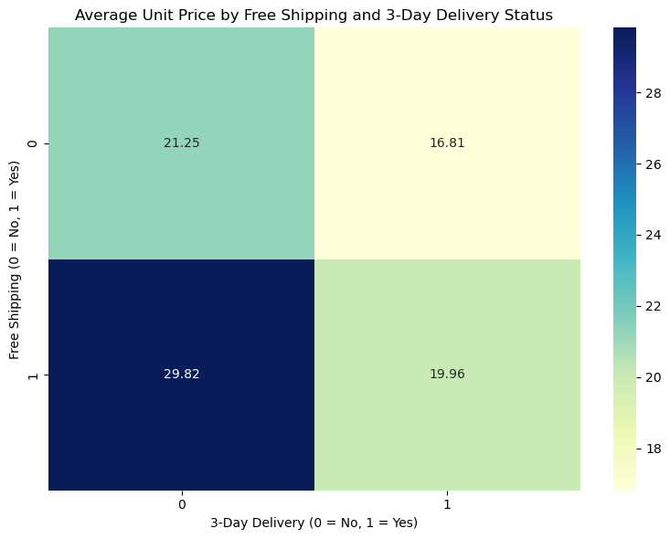
From this plot, we observed that products offering free shipping without fast delivery tend to have the highest average prices, while those offering both free shipping and 3-day delivery are priced more competitively.

